**Comparison of OHAS, NHTS-Portland and NHTS-Tampa Bay**

The results of OHAS, NHTS-Portland and NHTS-Tampa-Bay are similar. The results of NHTS-NHTS-Portland are not reasonable in some aspects, for example, travel time cost for HBW by low income group, which is probably caused by low sample size (2). The overall results of NHTS-Portland correspond with that of OHAS and NHTS-Tampa Bay.

**Statistics description**

**Table 1 Survey description**

|  |  |  |  |  |
| --- | --- | --- | --- | --- |
| Description | Script | OHAS | NHTS-Portland | NHTS-Tampa Bay |
| # of household | nrow(tcost.hh) | 4106 | 109 | 1246 |
|  | nrow(tcost.hh.tpurp) | 8167 | 252 | 2525 |

**Table 2 Counts of observation by household size**

|  |  |  |  |
| --- | --- | --- | --- |
|  | Count | | |
| Household size | OHAS | NHTS-Portland | NHTS-Tampa Bay |
| 1 | 1087 | 26 | 322 |
| 2 | 1529 | 42 | 616 |
| 3 | 677 | 14 | 144 |
| 4+ | 813 | 27 | 164 |

**Table 3 Counts of observations by trip purpose and income groups**

|  |  |  |  |  |
| --- | --- | --- | --- | --- |
|  |  | Count | | |
| Trip Purpose | Income group | OHAS | NHTS-Portland | NHTS-Tampa Bay |
| HBW | Low Inc | 206 | 2 | 45 |
| HBW | Mid Inc | 527 | 8 | 118 |
| HBW | High Inc | 2161 | 46 | 310 |
| HBS | Low Inc | 217 | 16 | 203 |
| HBS | Mid Inc | 345 | 7 | 263 |
| HBS | High Inc | 1136 | 51 | 363 |
| HBR | Low Inc | 78 | 9 | 107 |
| HBR | Mid Inc | 176 | 9 | 172 |
| HBR | High Inc | 873 | 43 | 266 |
| HBO | Low Inc | 288 | 8 | 138 |
| HBO | Mid Inc | 486 | 5 | 202 |
| HBO | High Inc | 1674 | 48 | 338 |

density_tcost.hh_by_inc.png

* OHAS

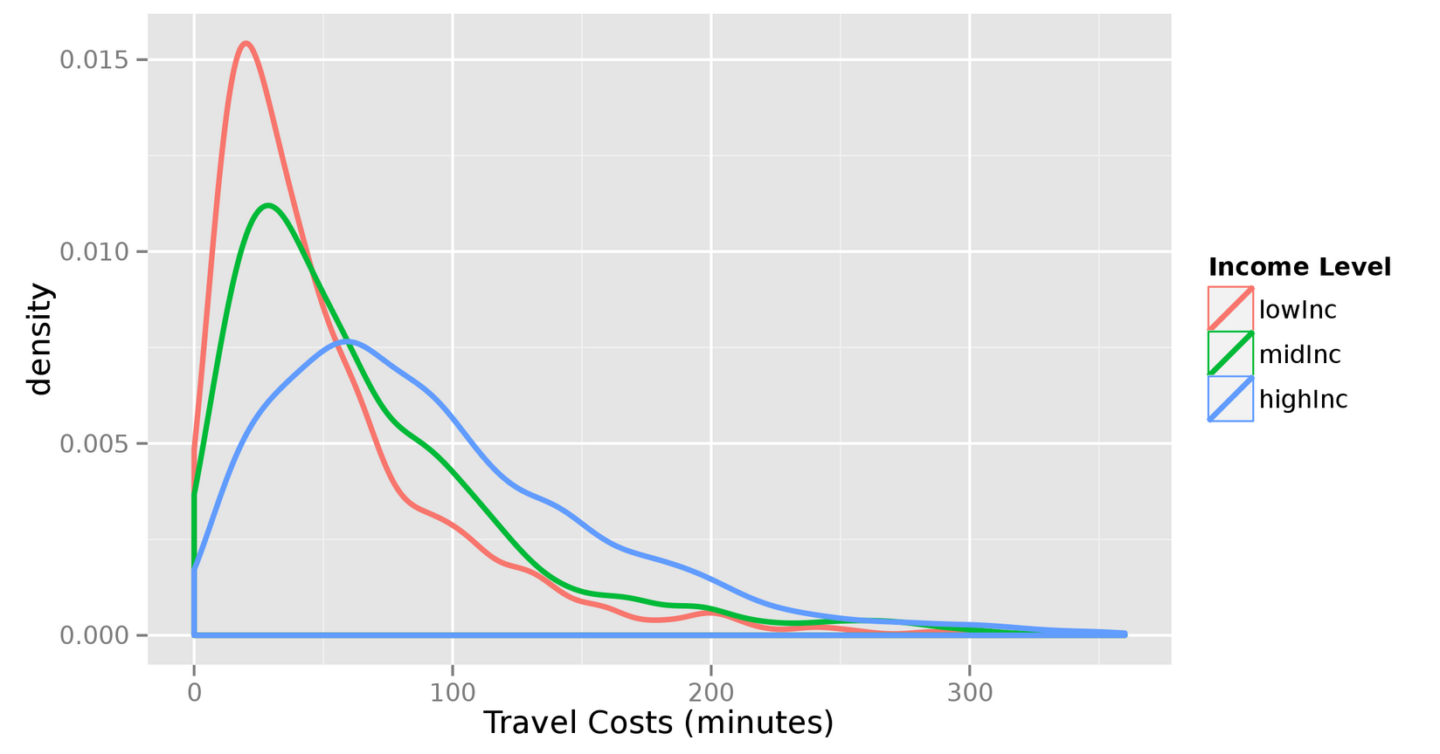

* NHTS-Portland

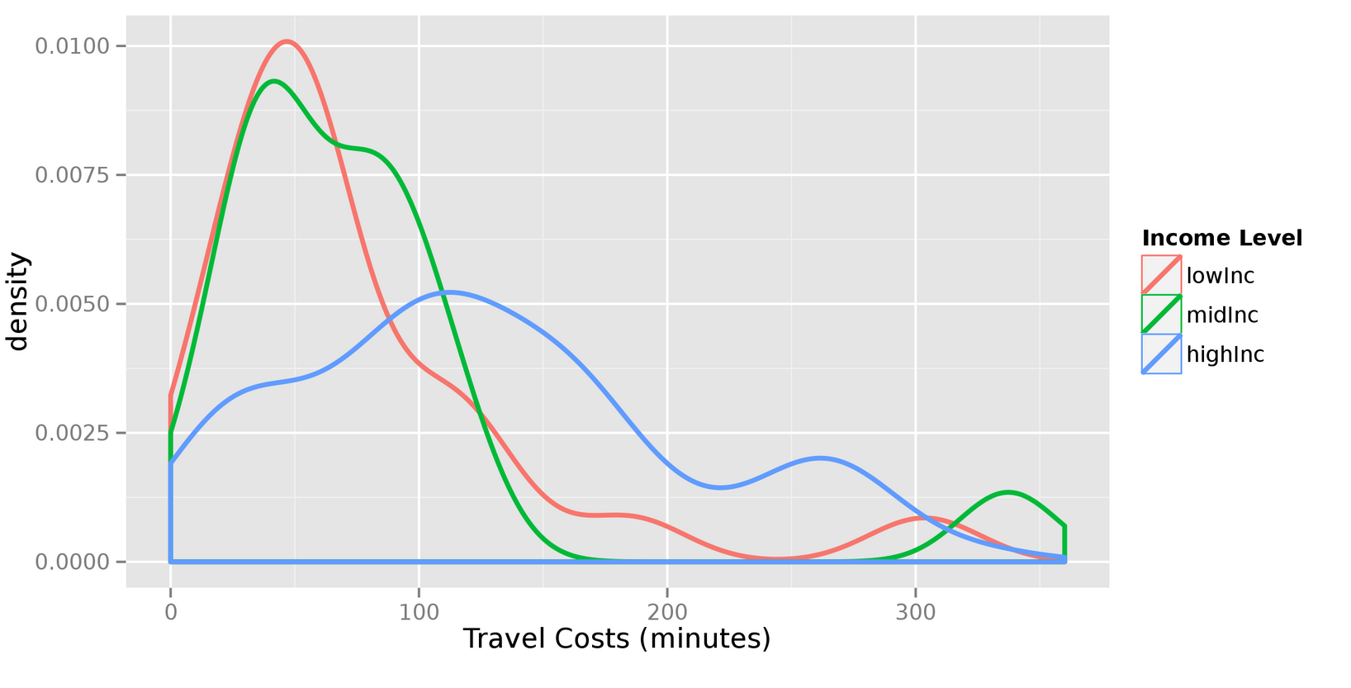

* NHTS-Tampa Bay

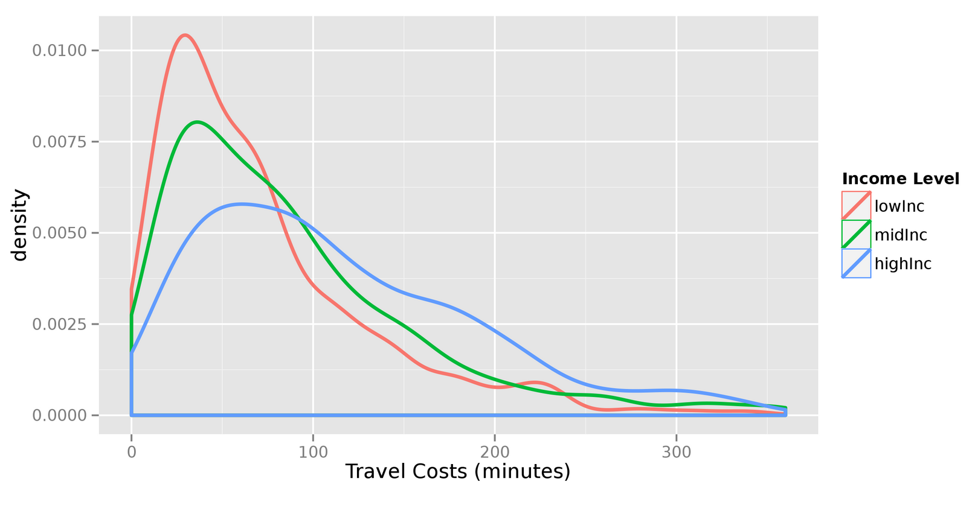

density_tcost.hh_by_hhsiz.png:

* OHAS

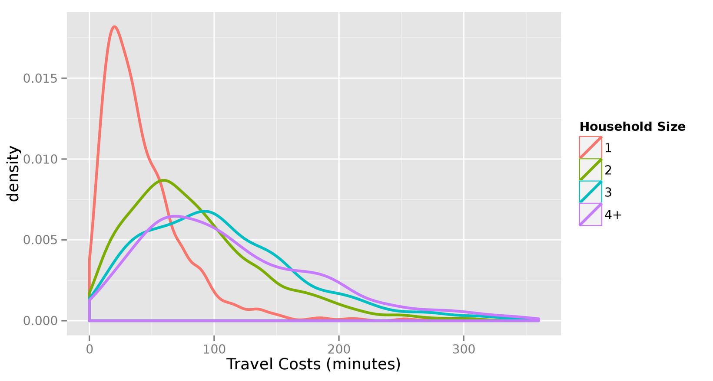

* NHTS-Portland

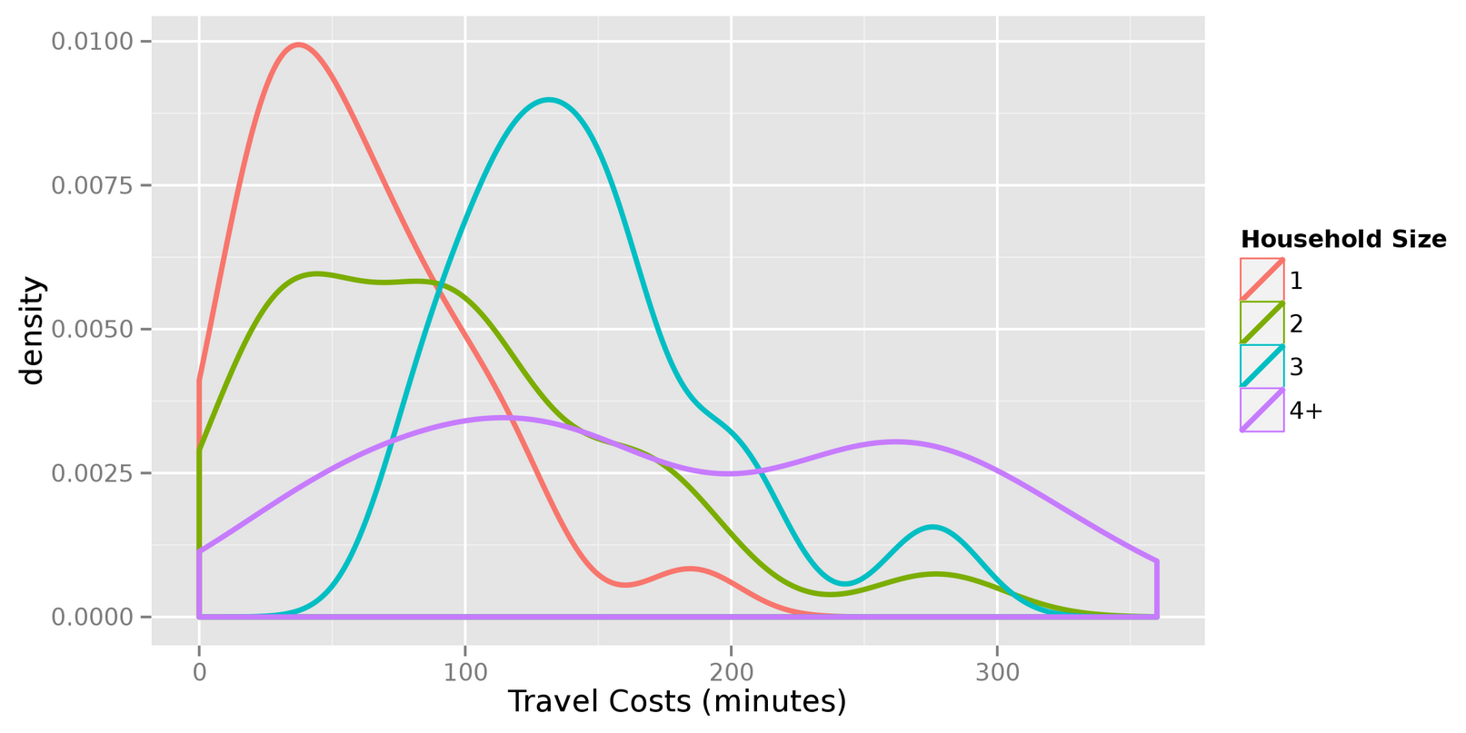

* NHTS-Tampa Bay

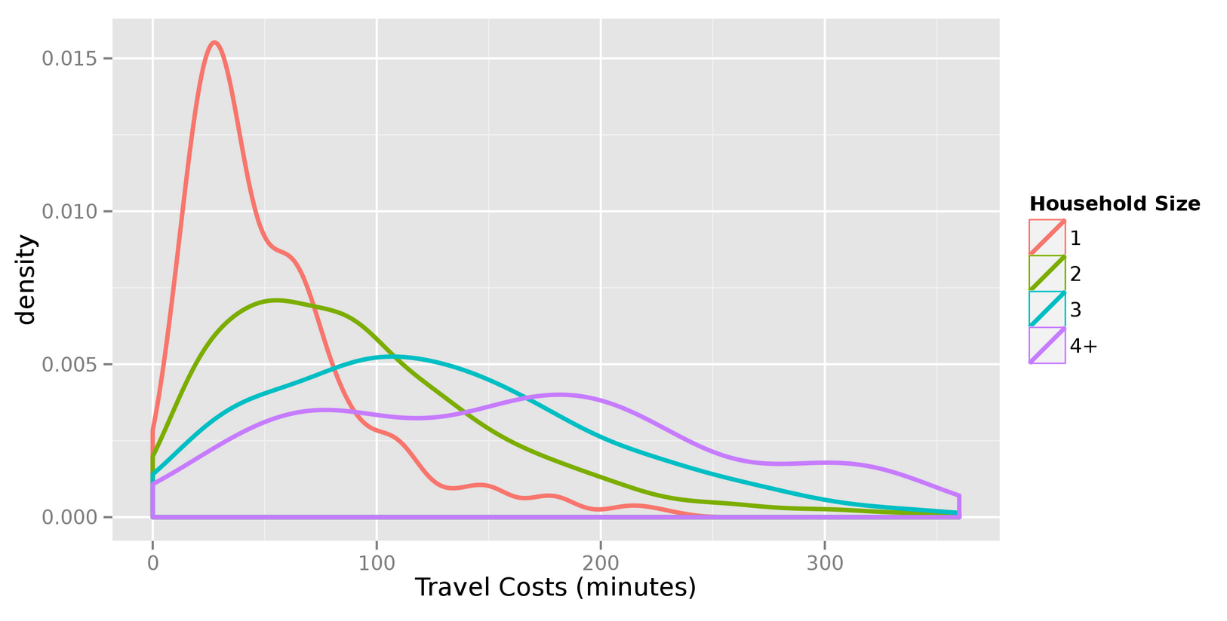

boxplot_tcost.hh_by_tpurp.inc.png

* OHAS

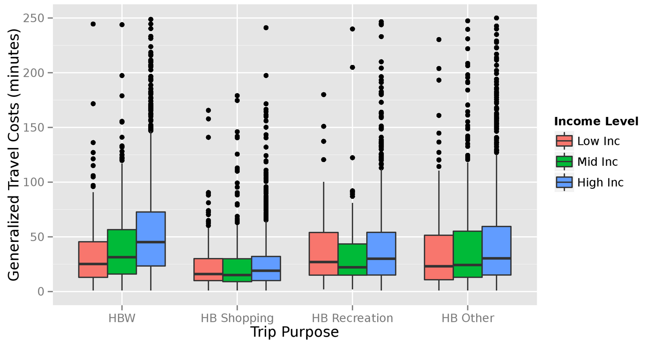

* NHTS-Portland

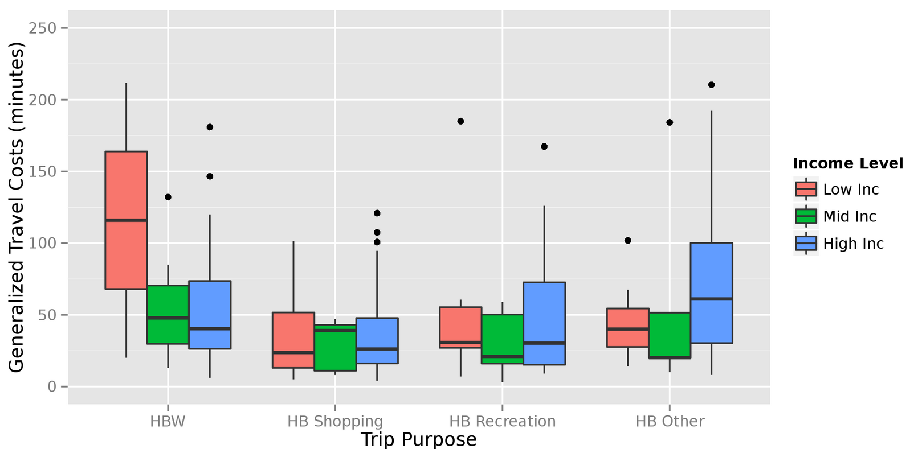

* NHTS-Tampa Bay

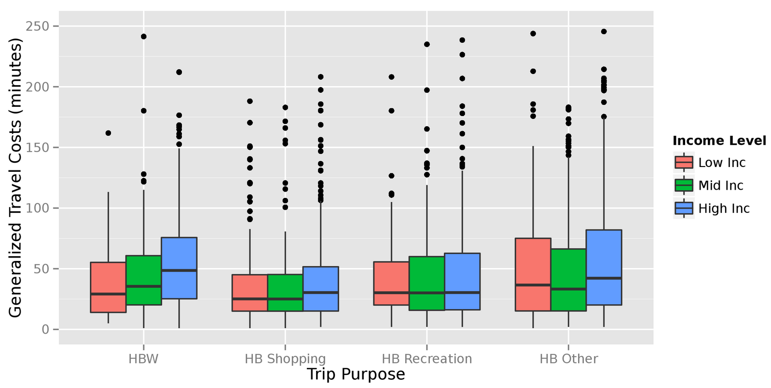

boxplot_tcost.hh_by_tpurp.inc.png.pdf

* OHAS

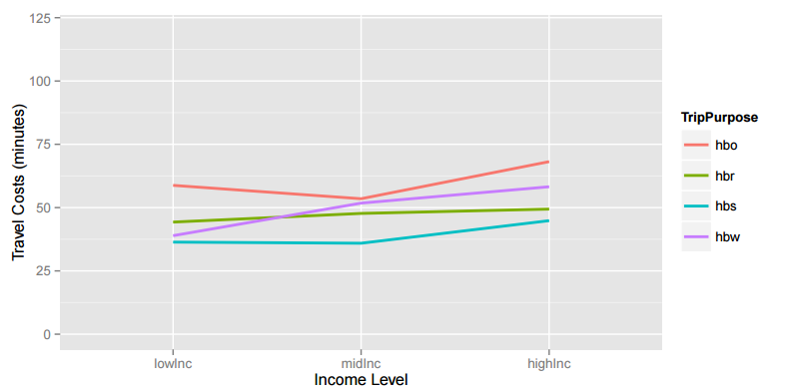

* NHTS-Portland

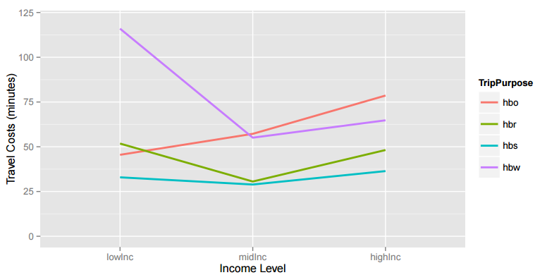

* NHTS-Tampa Bay

